NYC CITI BIKE ANALYSIS

Story can be found here:

<https://public.tableau.com/profile/> TBA

Dashboard 1: StartStations Dashboard

As to be expected the Manhattan area is where the most trip starts are occurring. This is most likely due to its tourism and density overall. This can be seen every month throughout the data set period. As you filter down the dataset you will find that all the top stations are not in one place, but rather different zip codes clustered around the Manhattan area.

The top Citi Bike Station is Grove St path in Manhattan, the maximum usages is during the warm summer season.

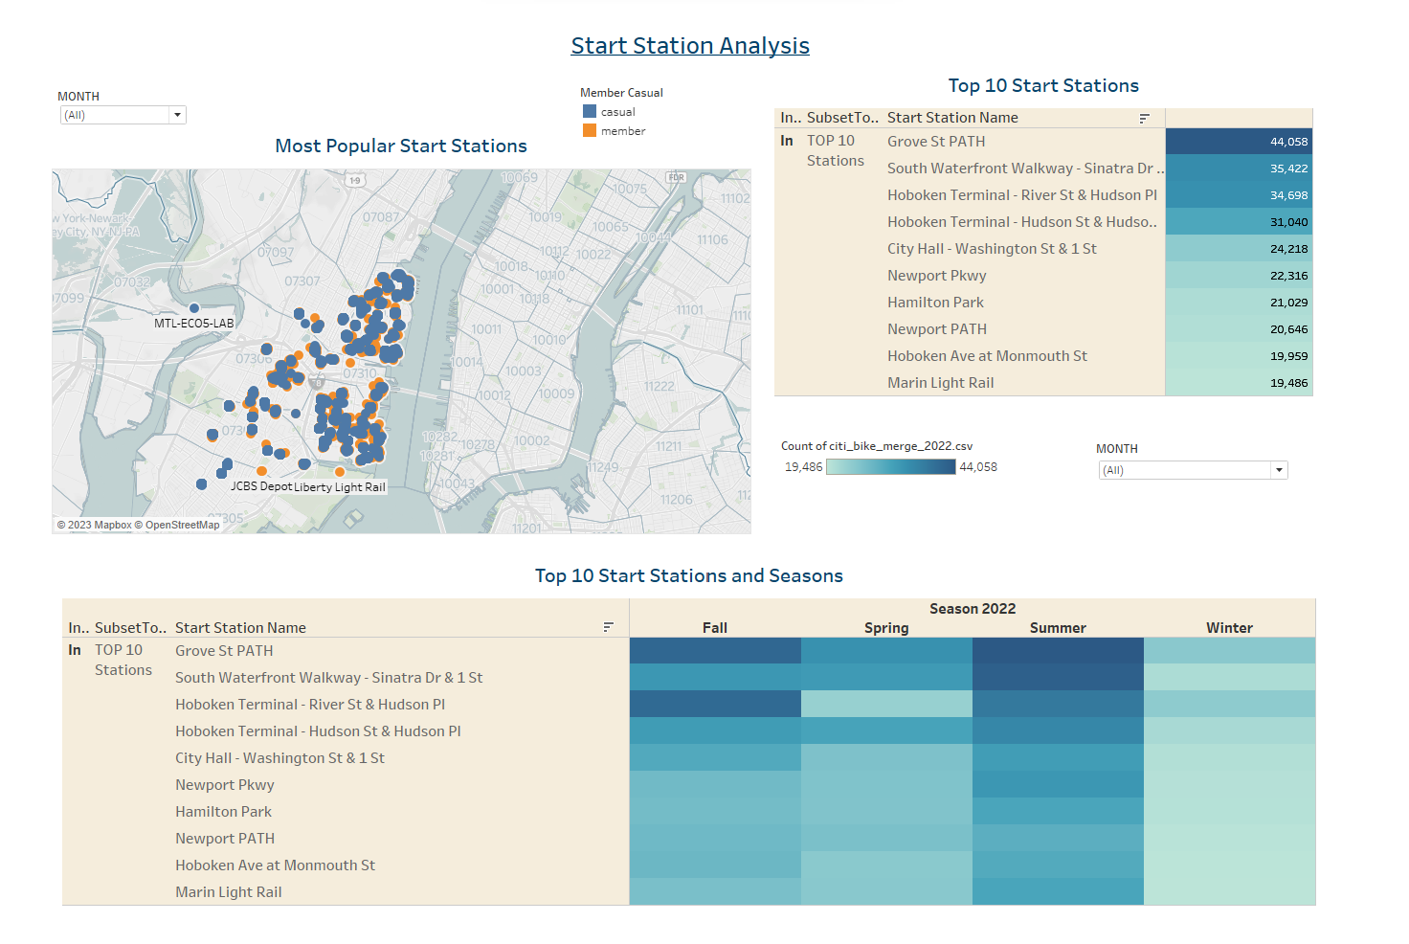

Dashboard 2:EndStations Dashboard  
  
As to be expected what goes out must come back in. for the most part start, and finish popularity are similar. Once again likely due to its tourism and density overall of the Manhattan area. This can be seen every month throughout the data set period. As you filter down the dataset you will find that once again in virtually the same locations, all the top stations are not in one place, but rather different zip codes clustered around the Manhattan area.  
The most popular End station is again Grove St PATH. Manhattan.

The most popular Ride type is Classic bike. While Electric Bike takes second best preference for riders.

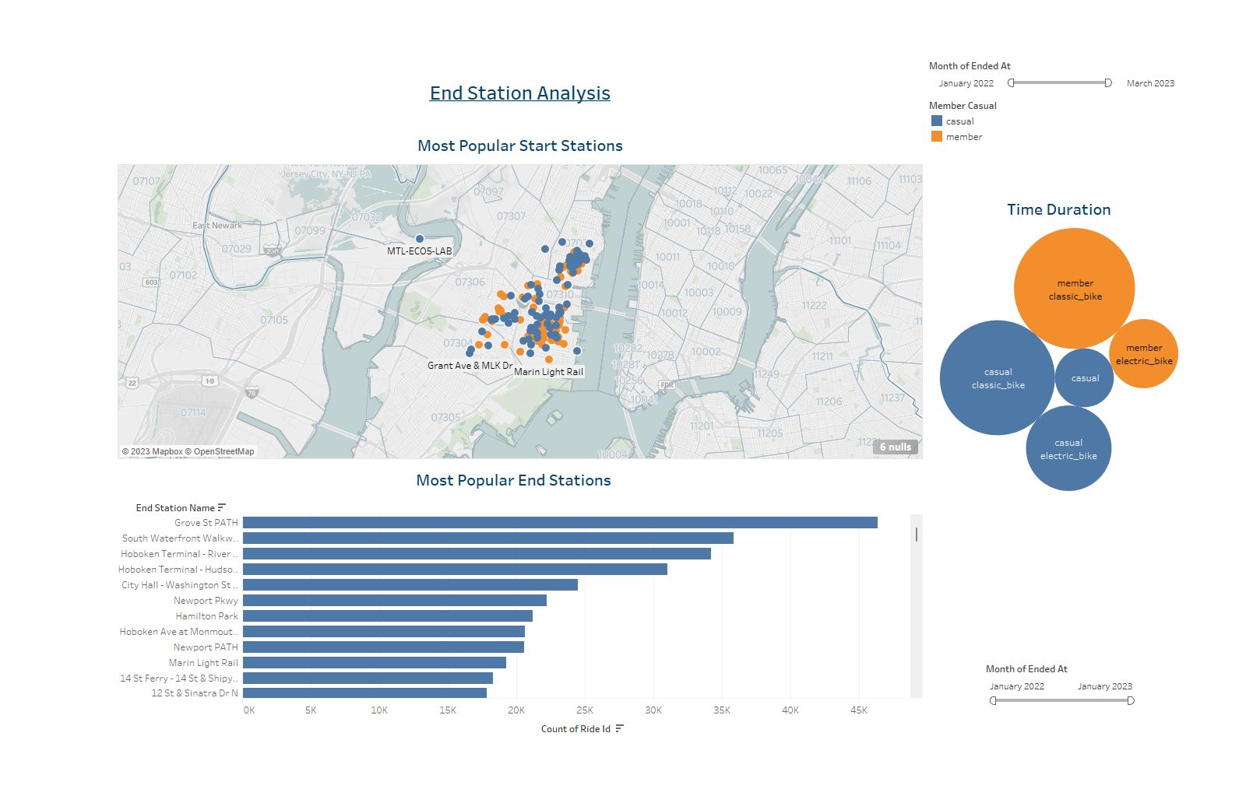

Dashboard 3: Seasons , Workhours riders and Age of Riders Analysis

During the period of Winter over 8 Million trips were recorded with the most occurring in before November 2022. Over all Trips die down as you move across this time period with an exception between January and February's numbers by 20259 rides

Overall Peak hours for the 2022 are between 2PM and 6PM. For this I included all months of 2022. The patter here follows that of day light during this time of year.

Looking at how average trip duration changes based on age you can see that there is a slight increase in ride time for those born 1996 - 2005 You can also see this for a few birth years in the 1940's and in 1969

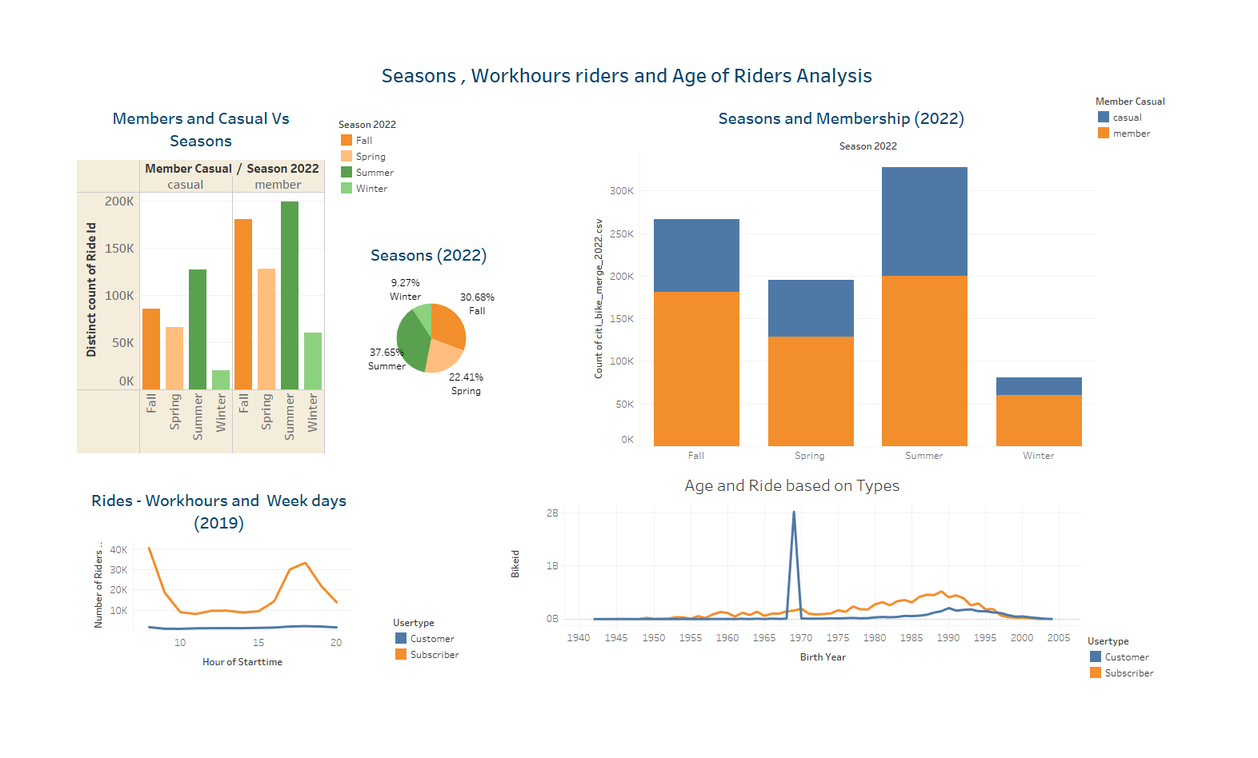

Dashboard 4: Membership status and Riders before and after Pandemic

Taking last month Fed 2023 and comparing with previous years.

Before Pandemic 2019 and 2020 Data shows more members but overall riders were between 3000 to 4000  
After Pandemic 2022 and 2023 Data shows more member also overall double the increase in riders (5500 – 8000)

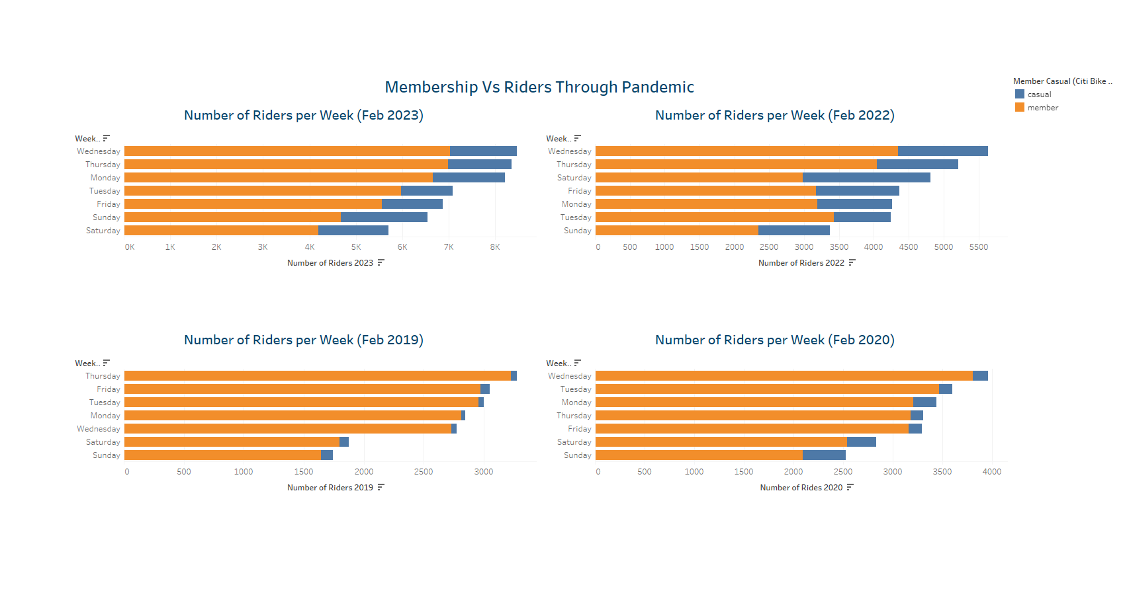

SLIDE 1: Start Stations

Interactions: Start Time Slider, Month Check List, Highlight Areas On The Map

Analysis: Map reflect Clusters of Riders – Casuals are lesser than members

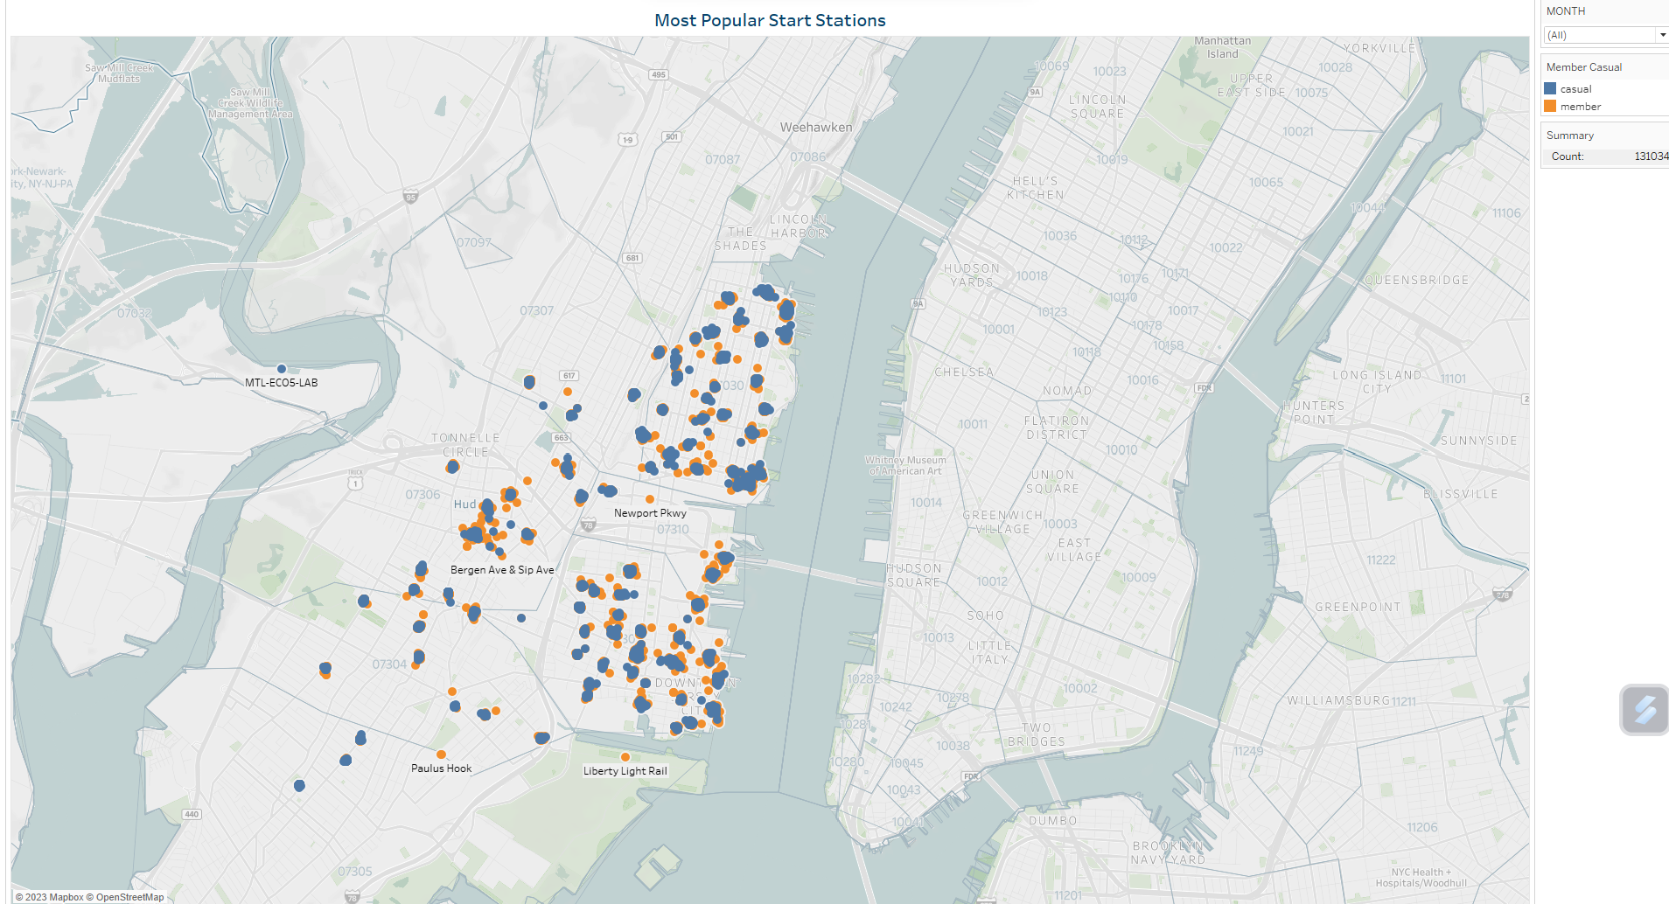

SLIDE 2: Top 10 Start Stations

Interactions: Drop Down For Months

Analysis: Looking at the table grove St Path is the popular start station.

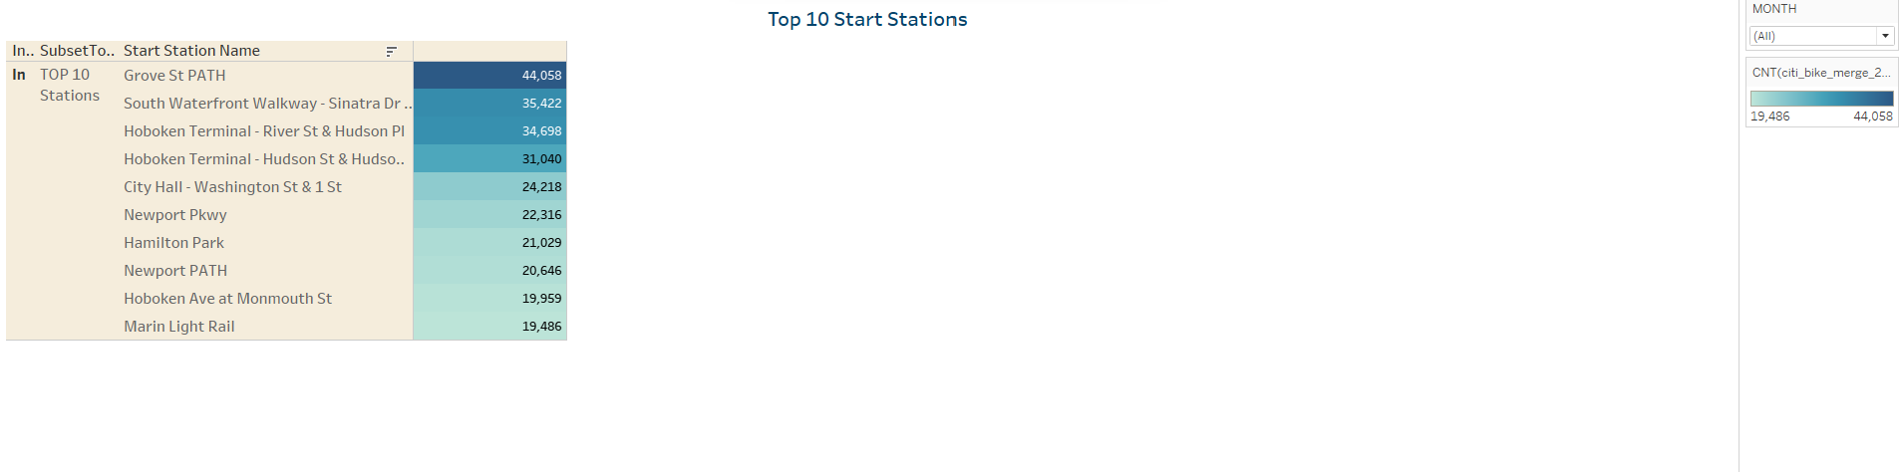

SLIDE 3: Top Start stations Vs Season

Analysis: This is a breakdown on the top stations during different seasons

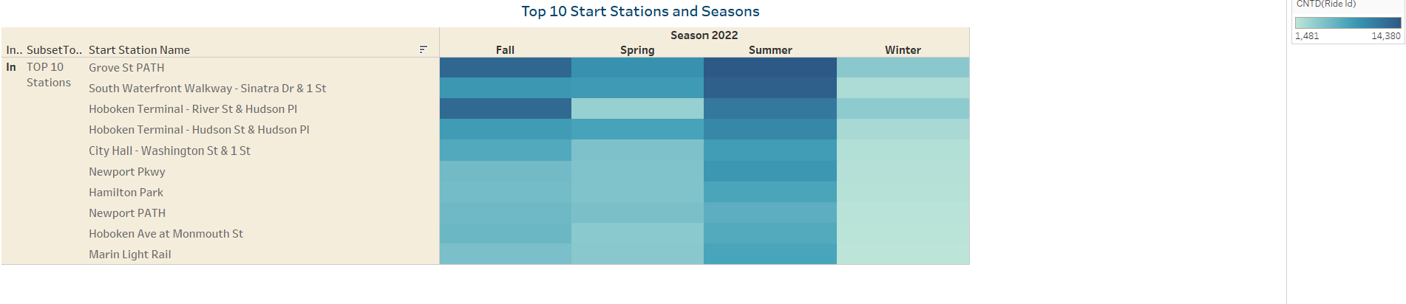

SLIDE 4: End Stations

Interactivity: End Stations Select by Monthly sliders while color coded by membership status. Overall crowds stay in the downtown

Analysis: During the period of Jan 22 to March 23 Map plotting show there are both Casuals and Members

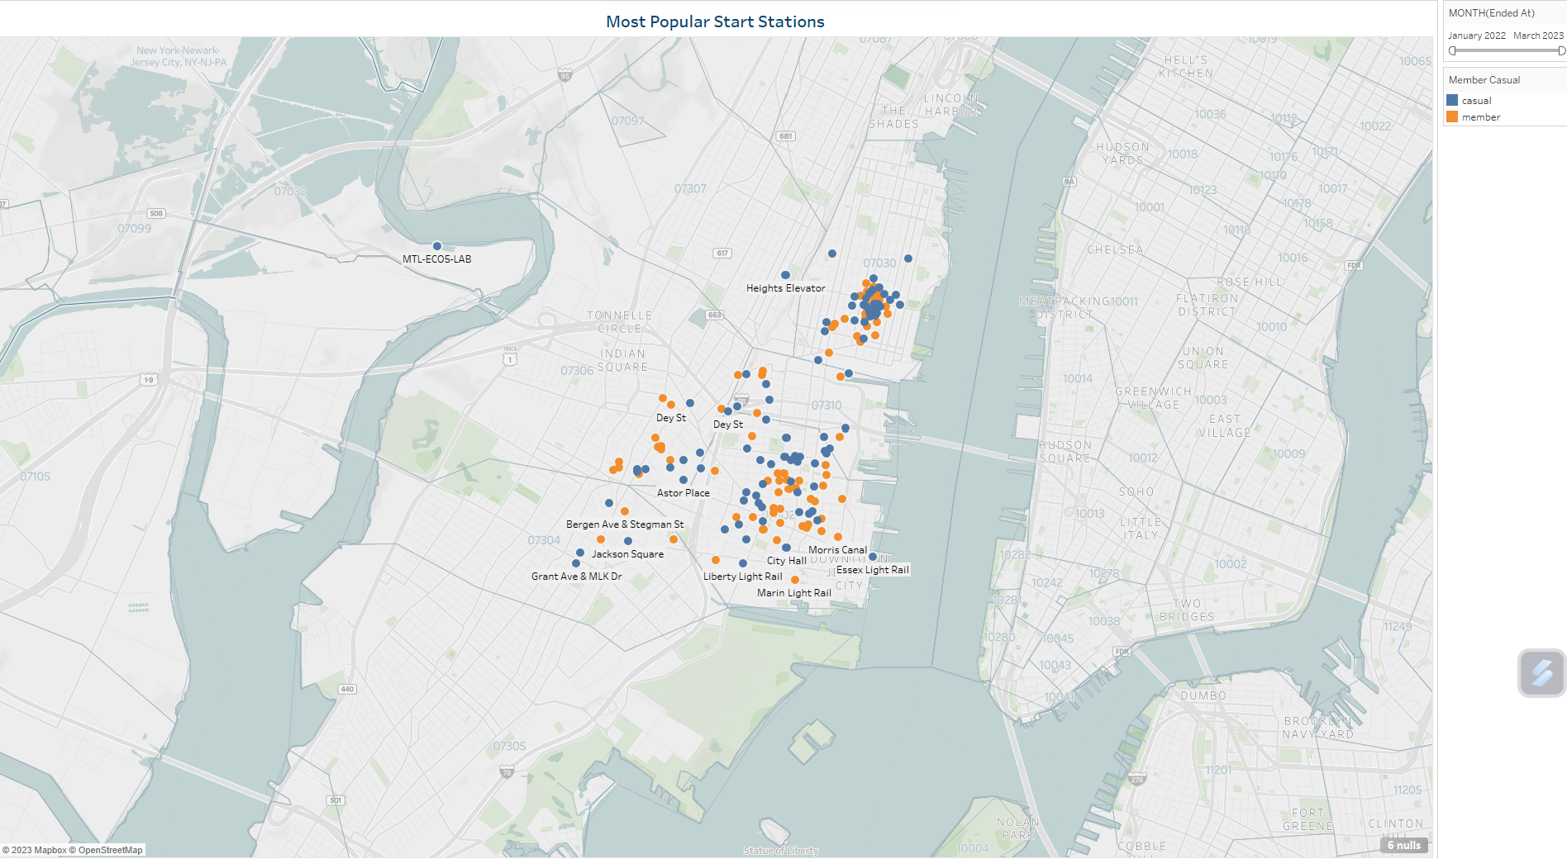

SLIDE 5: Most popular End stations

Analysis: Sorted in descending most popular End stations on a simple bar chart.

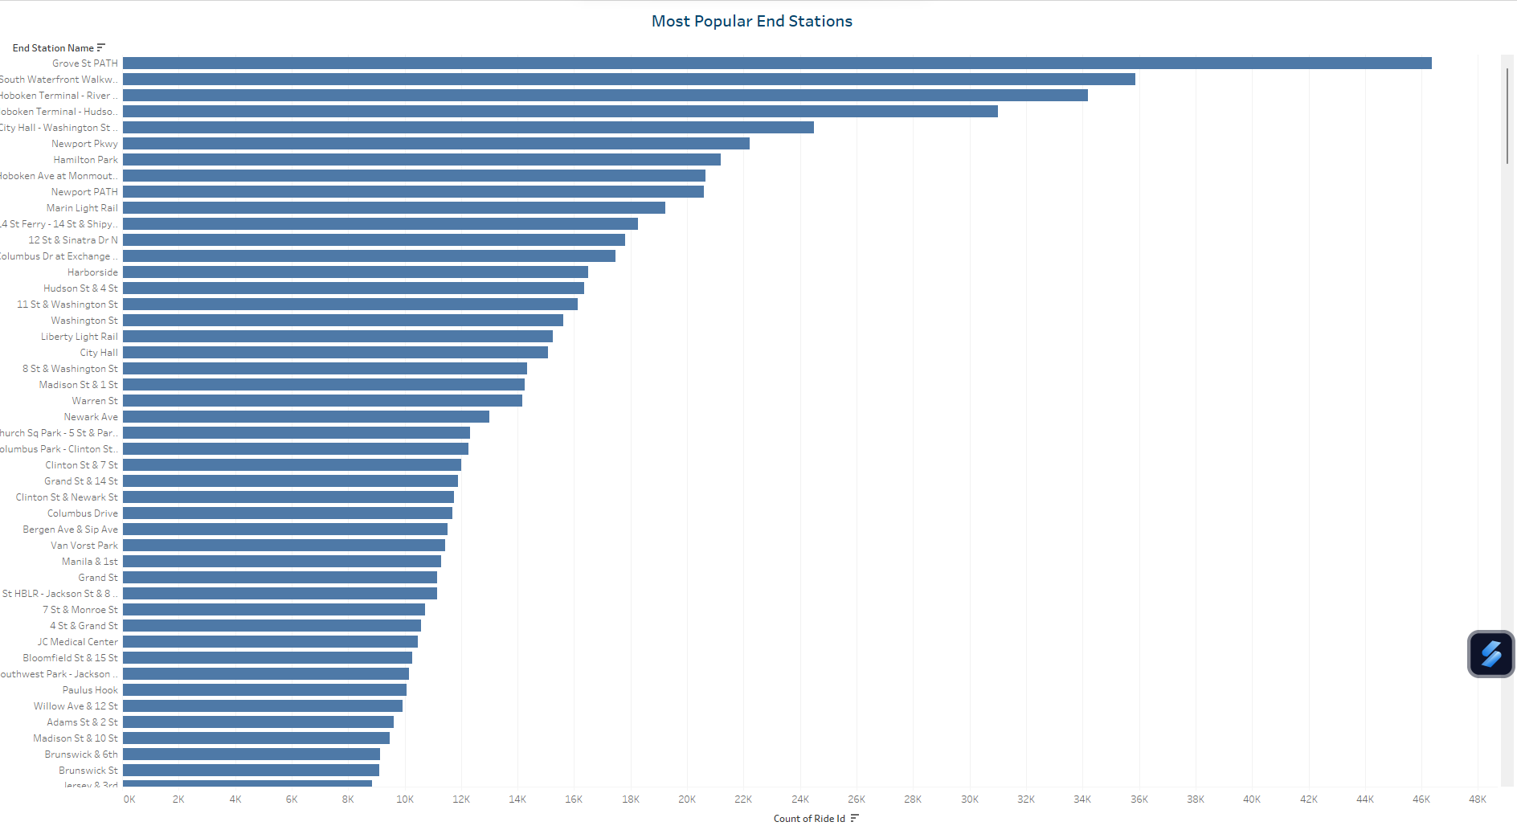

SLIDE 6: Time durations based on Ridable type

Analysis: Total Duration was more on Classic for both Members and Casuals, most popular type of ride is Classic bike.

**SUM(TimeDuration) of Bike rides : 10,909 Mins**

*Minimum: 870 Mins ride*

*Maximum: 3,674 Mins ride*

*Average: 2,182*

**Member Casual and Rideable Type.**

**Color shows details about Member Casual.**

**Size shows sum of TimeDuration.**

**The marks are labeled by Member Casual and Rideable Type.**

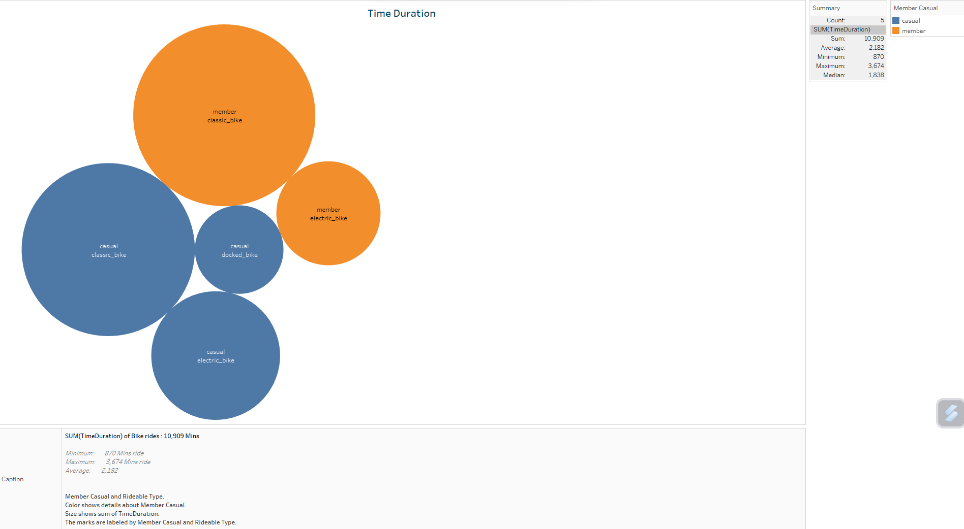

SLIDE 7: Members status Vs Seasons

Legend: Seasons(Grouped)

Analysis: Overall both short term customers and annual subscribers decrease dramatically throughout the data set period. In March the consumer base flips to more short-term customers that subscribers. Perhaps the weather have deterred folks from riding bikes outdoors during this period.

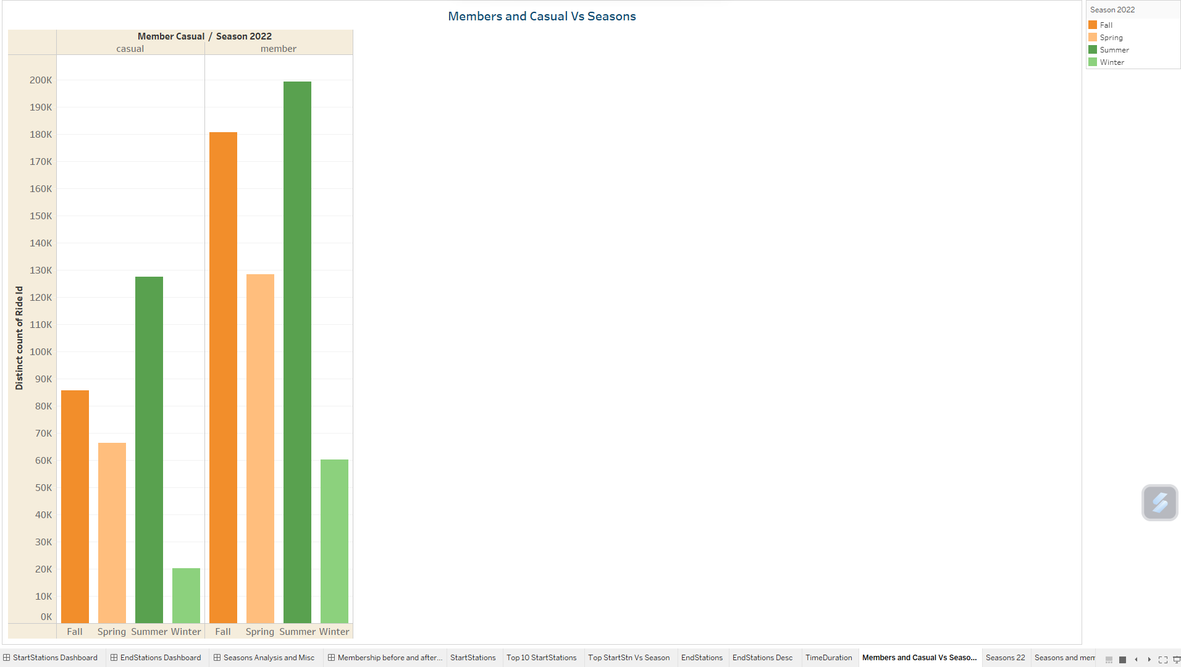

SLIDE 8: Season Pie

Analysis: As expected, Summer takes 37.65% of riders while Fall seconds as the memento from summer keeps the numbers running.

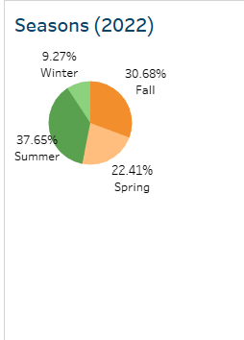 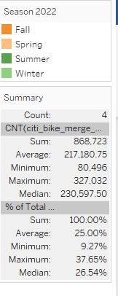 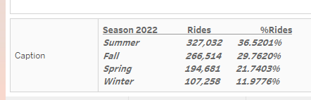

SLIDE 9: Seasons and Membership

Analysis: Members are the toppers throughout the seasons, while obviously Summer tops other season.

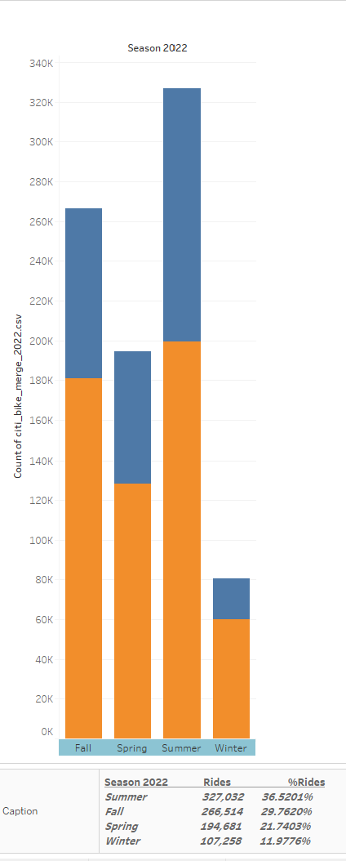 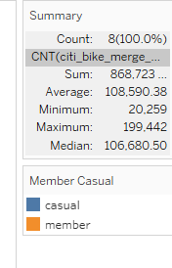 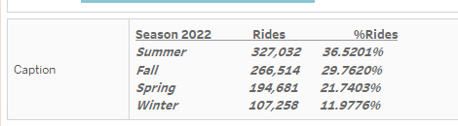

SLIDE 10,11,12,13:  
  
Analysis: Comparative bar chats for 2023,2022,2020,2019 Month of Feb analyzing the total number of riders and membership status.



SLIDE 14: Riders Weekdays (Hourly rides during Mon-Friday)

Analysis: The movement of bike riders are high during the mid-week and starts at the lower during the weekends and Mondays. The hourly rides shows high movements from 8 am to 10 am and from 4 pm to 6 pm

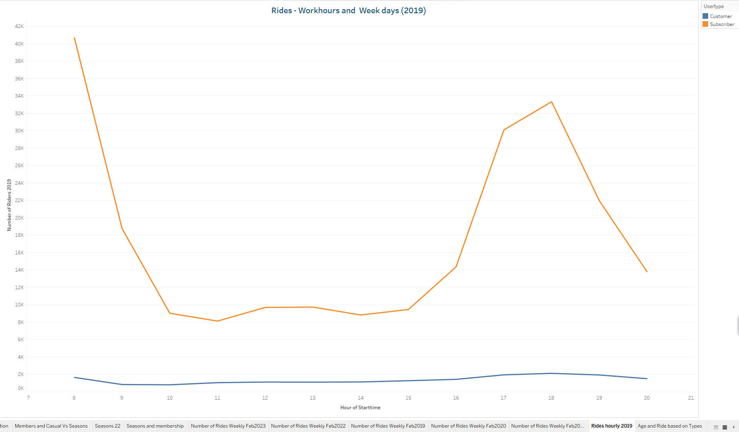

SLIDE 15: Age and Ride based on Types

Analysis: The Age group between 25-35 are the highest riders and more time durations.

